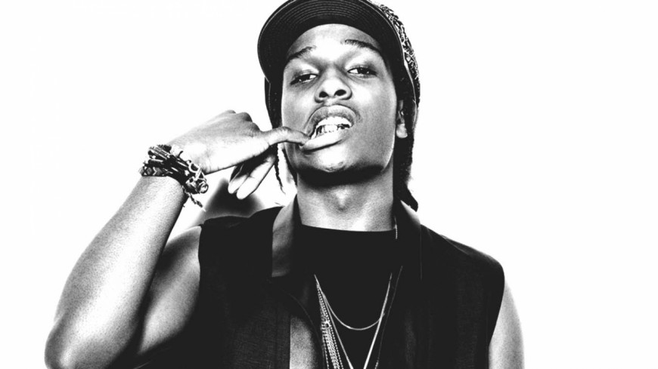

Rakim Mayers (born October 3, 1988), better known by his stage name ASAP Rocky (stylized as A $ AP Rocky), is an American rapper, songwriter, record producer, and actor.

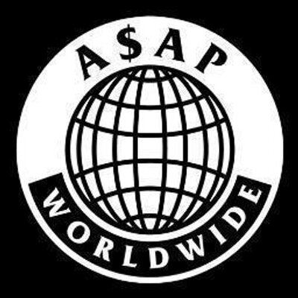

ASAP Mob (stylized as A$AP Mob) is an American hip hop collective formed in 2006, in Harlem, New York, by members ASAP Yams, ASAP Bari and ASAP Illz .most of whom carry the "ASAP" moniker, such as ASAP Rocky, ASAP Ferg, ASAP Twelvyy, ASAP Nast and ASAP Ant.

He and asap bari is a founder of a fashi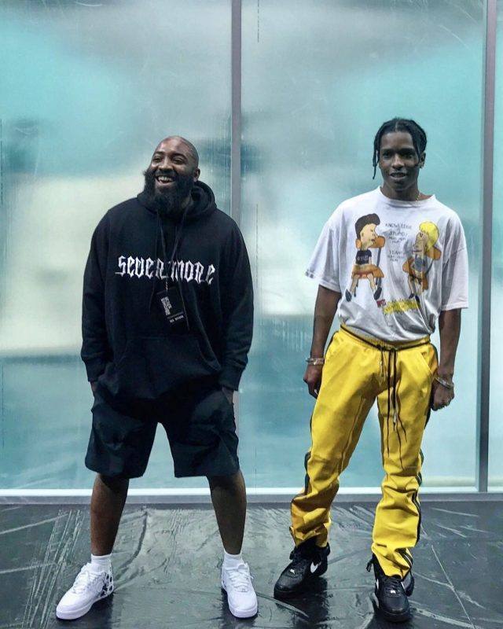on band “vlone”

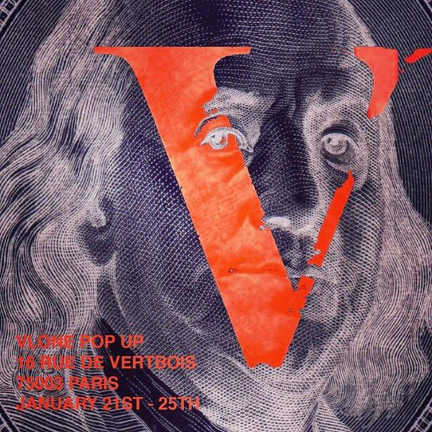

“vlone” has a pop up store at paris

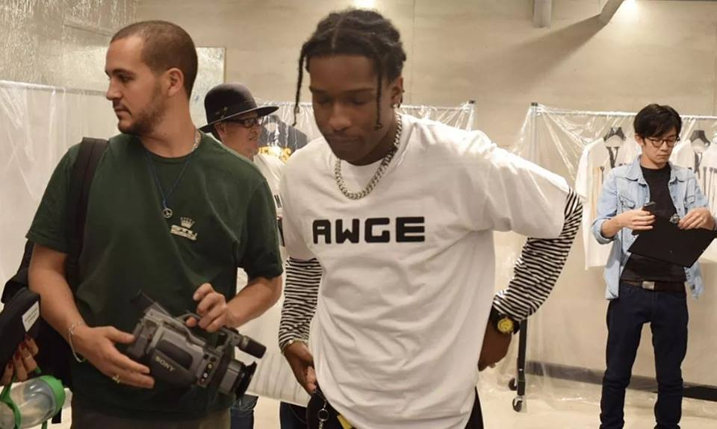

A$AP rocky create his own band AWGE by himself

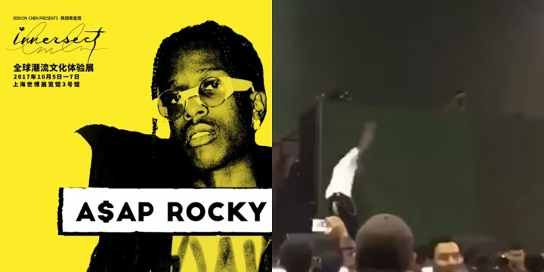

A$AP rocky take his team to perform in Shanghai

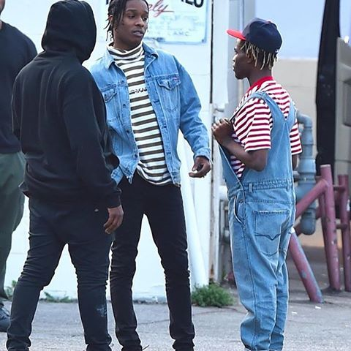

A$AP rocky meet a designer named ianconner

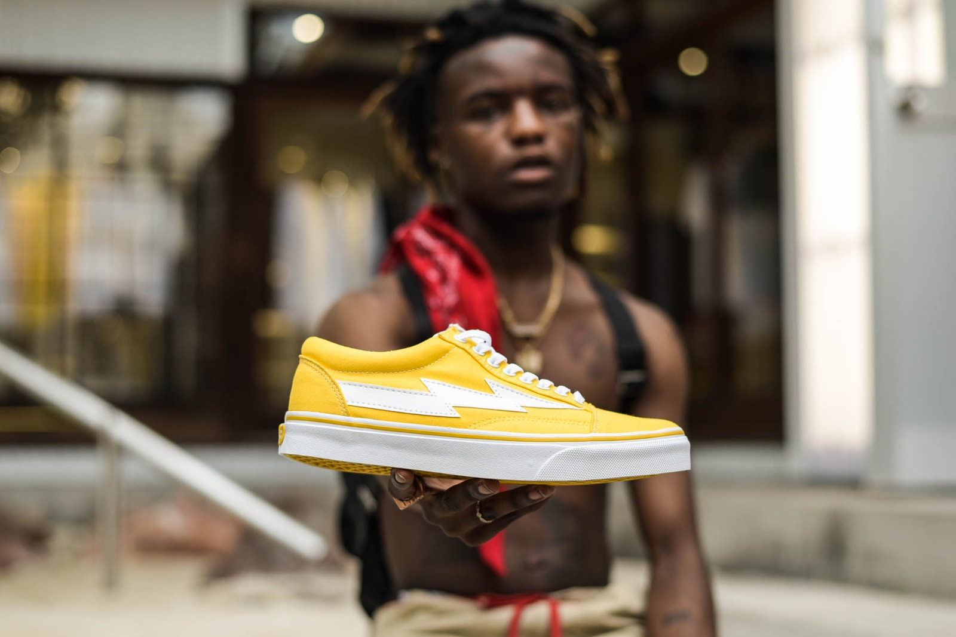

Ianconner create his own band revenge x storm by himself

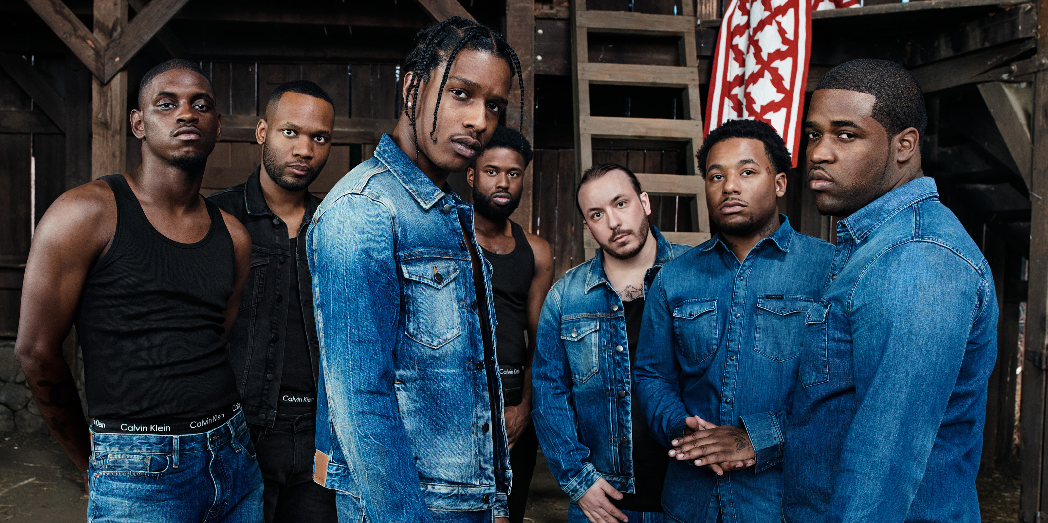

A$AP MOB endorsement of CK

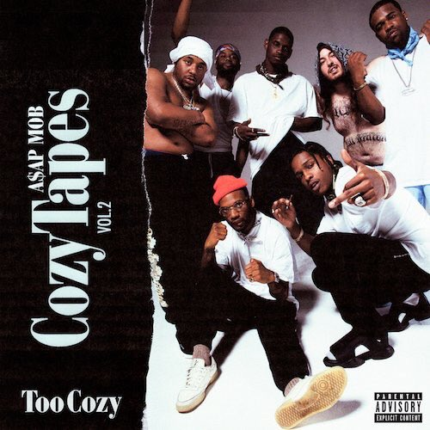

A$AP MOB in this year issued a new album